OpenWRT WireGuard Client Setup guide using LuCi
Latest iteration can be found at: https://github.com/egc112/OpenWRT-egc-add-on/tree/main/notes
There you can also find a guide to setup WireGuard as a Server.
Version 21

Introduction
These are my notes for setting up WireGuard as a Client.
In essence WireGuard is a peer -to-peer protocol but because of differences in setup we still make a distinction between setting it up as a Client or as a Server, but a WireGuard interface can be setup to function as a Client and Server at the same time.

This guide was made on a NetGear R7800 running OpenWRT 24.10.0, screenshots are made with OpenWRT2020 theme which is not much different from the default theme.

My notes are using the easy way with a simple setup using LuCi although the corresponding config files are also listed.
This simple setup is done by importing a config file (.conf) from your VPN provider with necessary settings (see: config file ).
Importing a config file is possible if you installed the wg-tools package (see Install WireGuard).
But just adding the settings manually will also do the trick.

Other useful information can be found in the OpenWRT WireGuard wiki.
Index
Introduction 1
Install WireGuard 2
Download configuration 2
Create WireGuard interface 4
For a typical client setup the listen port should be left empty, meaning a random listen port. 5
Advanced Settings: 5
Create WireGuard Peers section 5
Firewall 8
Easy method 8
Alternative Method 10
Allowing Specific client(s) WAN access 12
Check 12
DNS Leak 12
WireGuard Client on a BridgedAP 13
Policy Based Routing on the Bridged AP 14
Asking for Help 14
References 14
Miscellaneous 15
Setup IPv6 on a bridgedAP 15
Prevent Mullvad from hijacking your DNS 15
Port forwarding via Proton VPN with natpmpc 15
MTU size problems (no traffic, hang, slow loading, no streaming media, bad VoiP, slow RDP) 15
WireGuard Watchdog 15
WireGuard Companion 16
Custom user files for Azure, AWS etc 16
Centralized Management and Deployment 16
Binding WireGuard interface to specific wan interface in case of multiwan 16

Install WireGuard

Prerequisite for installing is a fully functioning router with the correct time.

LuCi > System > Software: click Update Lists
Install: luci-proto-wireguard (wireguard-tools should be installed automatically)

Download configuration
If you already have a configuration file then go to Create WireGuard interface, otherwise download a WireGuard configuration file from your provider or WireGuard Server.
In this example we are going to download a WireGuard configuration file from Proton which is free but it will expire after a week or so:
Create an account on https://protonvpn.com/
Login
Go to Downloads and scroll to the bottom for the WireGuard configuration.

Give a name to your config and choose router for your Platform :

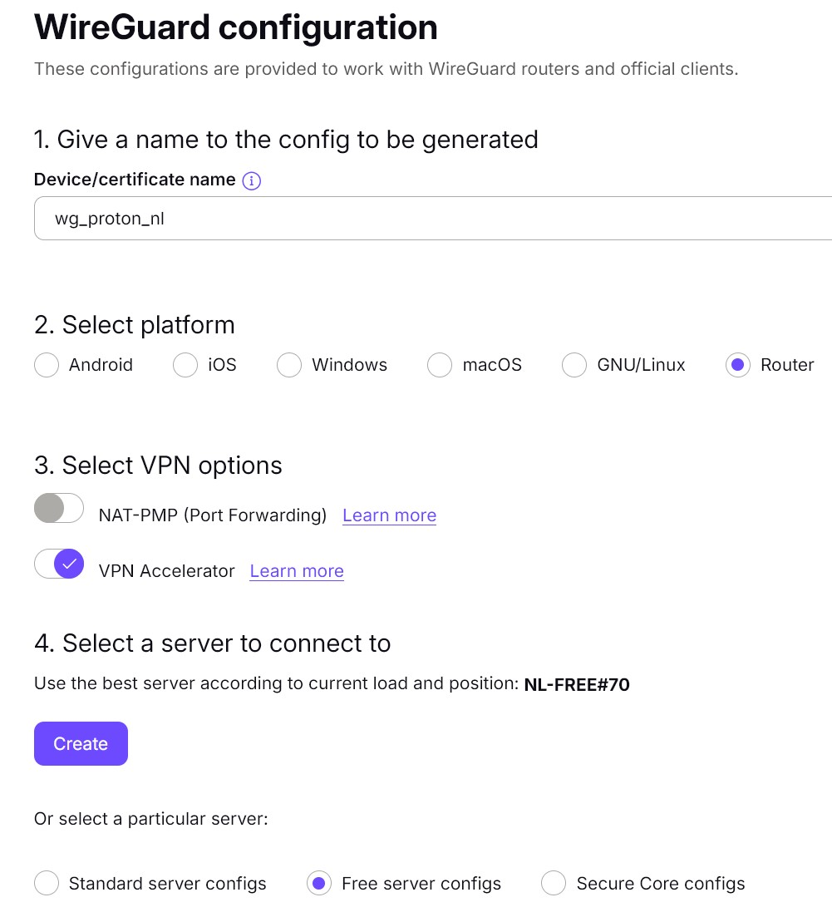

Scroll down to the server you want to connect to and Choose Create:
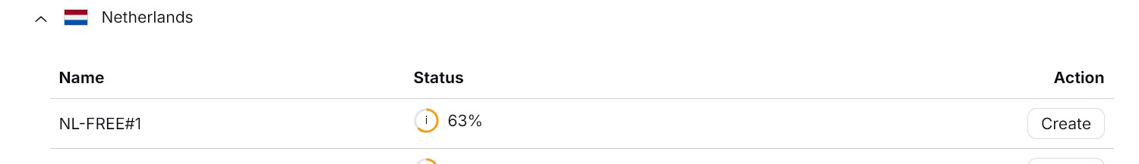

Download the config file to your computer, the config file (wg_proton_nl-NL-FREE-1.conf) looks like this:
[Interface]
# Key for wg_proton_nl
# Bouncing = 3
# NAT-PMP (Port Forwarding) = off
# VPN Accelerator = on
PrivateKey = UJmovcwC7KQ/vfgnradTHoHD30WJ6SonkvXYg23ex0A=
Address = 10.2.0.2/32
DNS = 10.2.0.1

[Peer]
# NL-FREE#1
PublicKey = vH2i8RY1qc66XfqwrixBpvH4K9GYJatkugJj0GHgoUQ=
AllowedIPs = 0.0.0.0/0
Endpoint = 217.23.3.76:51820

Add PersistentKeepAlive with value 25 so that the connection stays open:
PersistentKeepalive = 25
and if you use IPv6 add ::0/0 to allowed IPs:
AllowedIPs = 0.0.0.0/0, ::/0

The result:
[Interface]
# Key for wg_proton_nl
# Bouncing = 3
# NAT-PMP (Port Forwarding) = off
# VPN Accelerator = on
PrivateKey = UJmovcwC7KQ/vfgnradTHoHD30WJ6SonkvXYg23ex0A=
Address = 10.2.0.2/32
DNS = 10.2.0.1

[Peer]
# NL-FREE#1
PublicKey = vH2i8RY1qc66XfqwrixBpvH4K9GYJatkugJj0GHgoUQ=
AllowedIPs = 0.0.0.0/0, ::0/0
Endpoint = 217.23.3.76:51820
PersistentKeepalive = 25

Note that there is no listen port in the Interface section, if you have a config file with a listen port then I recommend to delete the listen port so that the router can choose its own port which is not already taken.

Create WireGuard interface
Network > Interfaces on the bottom click: Add New interface
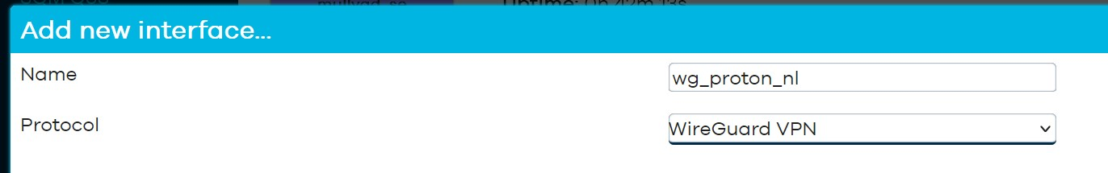
Name: give a descriptive name, hyphens are not allowed and the name has to be less than 15 characters!
Protocol: WireGuard VPN

Click: Create interface
The Interface configuration screen should appear: 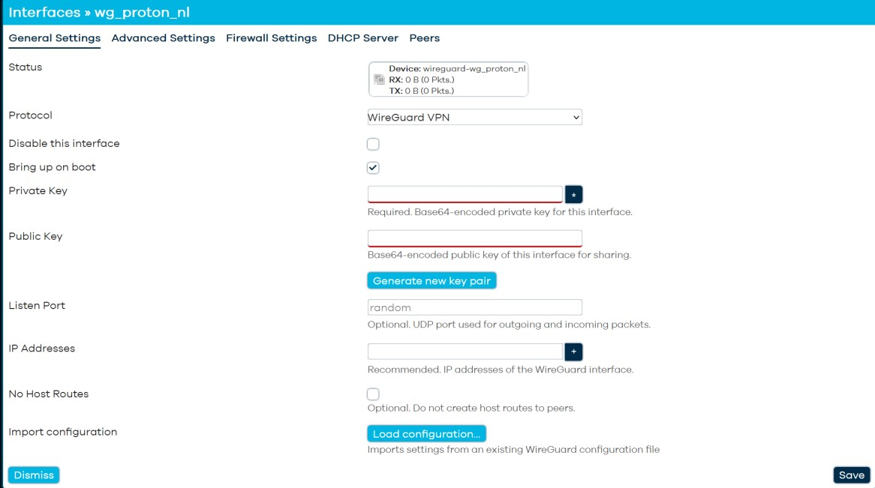

We can now import our configuration file by clicking the button Load configuration
Click: Load configuration
Drop the configuration file from the file manager into this box and automagically the settings should appear into the Interfaces configuration: 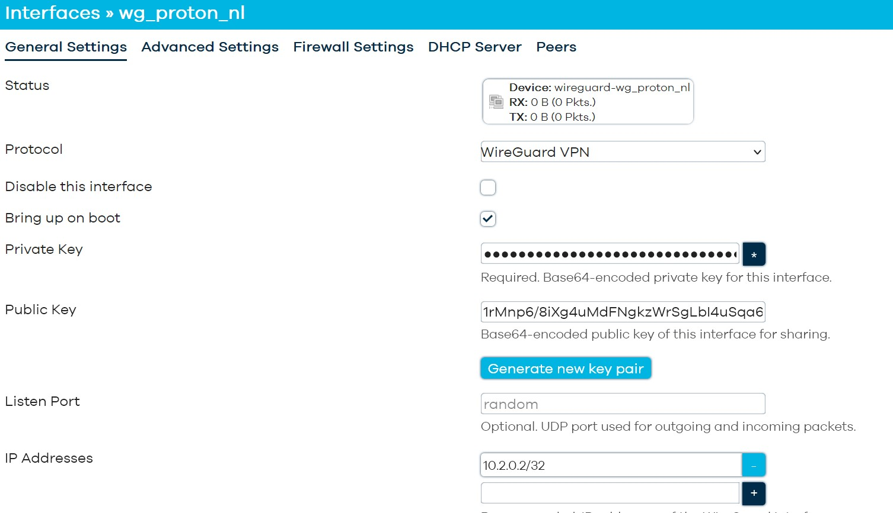

For a typical client setup the listen port should be left empty, meaning a random listen port.

Advanced Settings:
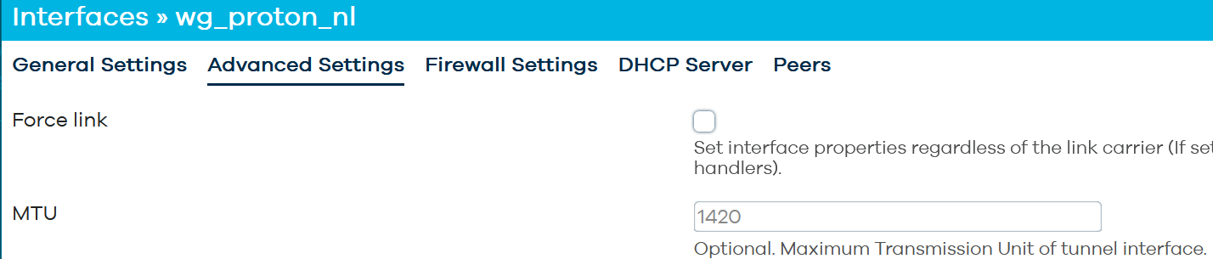
MTU: can usually be left at its default setting (1420 or 1412 for PPPoE).
On occasion if you have slow or hanging connections especially when streaming, you have to lower the MTU, start lowering to 1280, but sometimes you have to go even lower. For some further explanation see MTU size problems at the end of this guide.
Note that you also have to enable MSS clamping (option mtu_fix '1') on the firewall zone the WireGuard interface is added to but this is covered in the firewall settings.

Create WireGuard Peers section
Network > Interfaces > wg_proton_nl: click edit
Go to Peers section:
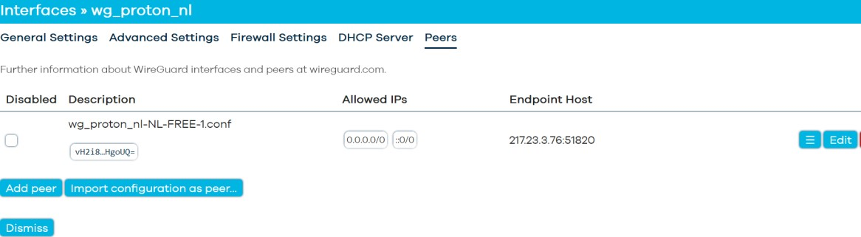

Click: Edit and the Peers section will open: 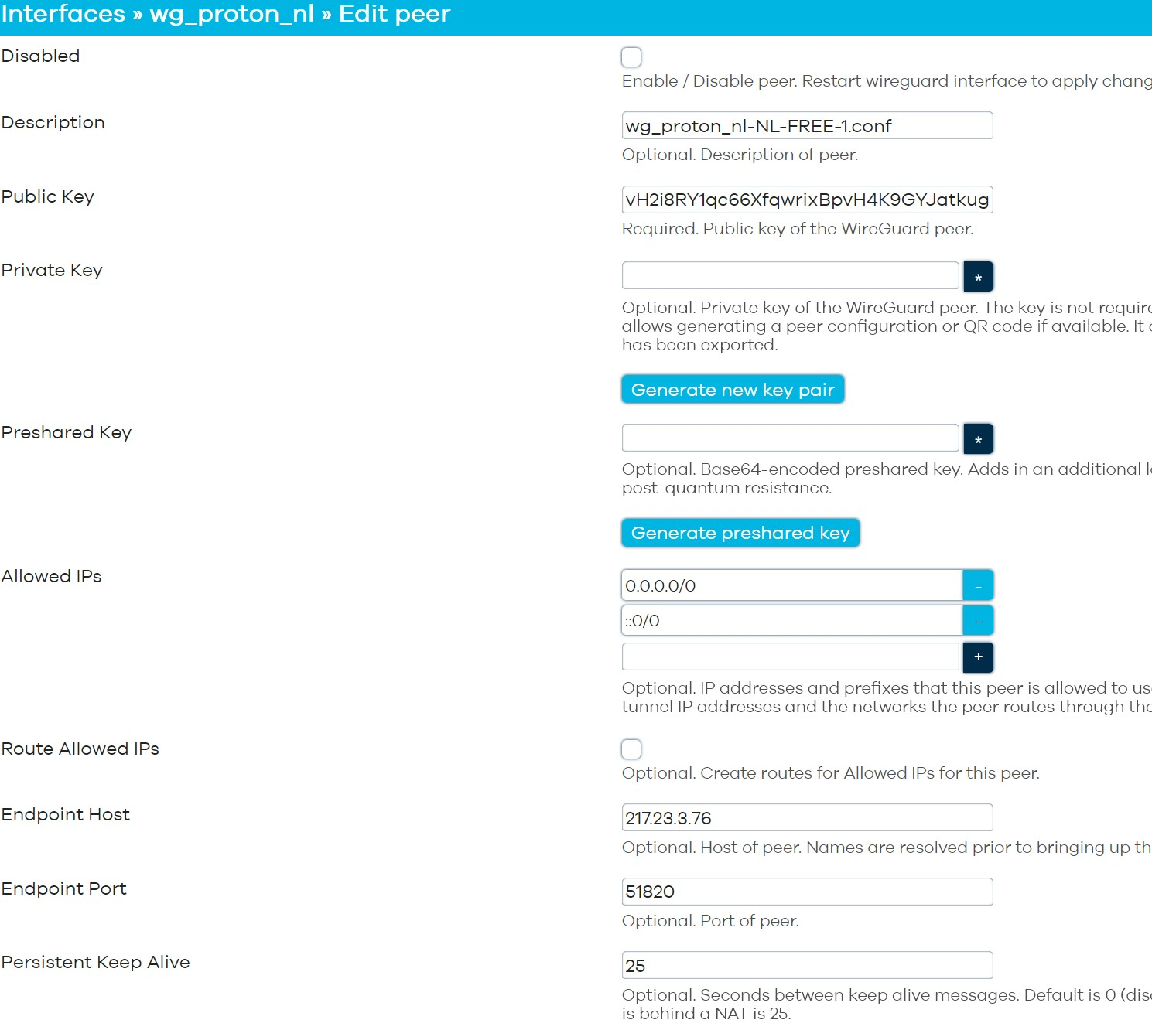

Most settings should be automatically imported from your uploaded config but carefully check it:
- Public key: this is the public key of the server
- Allowed IPs: are set both for IPv4 (0.0.0.0/0) and for IPv6 (::0/0), for IPv6 only necessary if you have IPv6 implemented on your router.
- Route Allowed IPs: Enable (tick), this is not automatically set so must be done
- Endpoint Host: this is the IP address or Domain name of the server
- Endpoint port: this is the port the server is listening on, often this is 51820 but it could be different.
- Persistent Keep Alive: 25, Check that this value is set, this keeps the connection alive

Click: Save
In the next window Click: Save again
In the Interface window click Save & Apply

/etc/config/network:
config interface 'wg_proton_nl'
option proto 'wireguard'
option private_key 'UJmovcwC7KQ/vfgnrasdfggdfgdfgdgddsgfdc='
list dns '10.2.0.1'
list addresses '10.2.0.2/24'

config wireguard_wg_proton_nl
option description 'wg_proton_nl-NL-FREE-1.conf'
option public_key 'vH2i8RY1qc66XfqwrixBpvH4K9dsfge4egdfgdfger='
option endpoint_host '217.23.3.76'
option endpoint_port '51820'
list allowed_ips '0.0.0.0/0'
list allowed_ips '::/0' # leave in place for PBR
list allowed_ips '::/1'
list allowed_ips '8000::/1'
option route_allowed_ips '1'
option persistent_keepalive '25'

IPv6 is not supported by all providers. If the provider hands out an IPv6 address besides an IPv4 address it should be supported.
Proton does not support IPv6 but setup is covered for other providers!
In case your provider does not support IPv6 you can skip the IPv6 sections

Note for IPv6 either
1. add `::/1` and `8000::/1` as Allowed IPs to create a default route, this has the "benefit" of reinstating default route via wan6 if the interface is disabled
or
2. Disable Source routing (Interfaces > Network > wan6 > Advanced tab: untick/disable IPv6 source routing and set the wan6 gateway metric to 512 to be the same as your VPN interface (note this looks broken), alternatively set wan gateway metric and WireGuard interface metric both to 256 on the Advanced Interface tab.

etc/config/network:
config interface 'wan6'
option sourcefilter '0'`

Alternatively you can work with metrics and set appropriate metrics on WG interface and higher metrics on default route in wan and wan6, but this is more complicated as default metrics for IPv4 and IPv6 are not the same.

Next up Firewall

Firewall

Easy method
Easiest method is to just add the wg_proton_nl interface to the WAN zone

Network > Firewall > WAN zone > Click: edit:
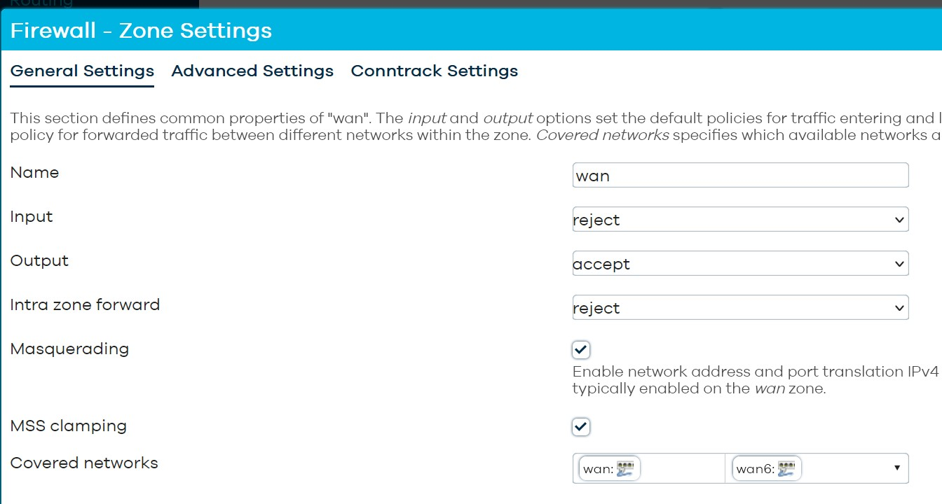

Covered Networks: add wg_proton_nl

For IPv6 enable IPv6 Masquerading on the WireGuard firewall zone:
Advanced settings > Enable IPv6 Masquerading
but restrict this to the IPv6 subnet of the WireGuard interface, this is the IPv6 IP/List Addresses in the WireGuard interface but with a /64 netmask

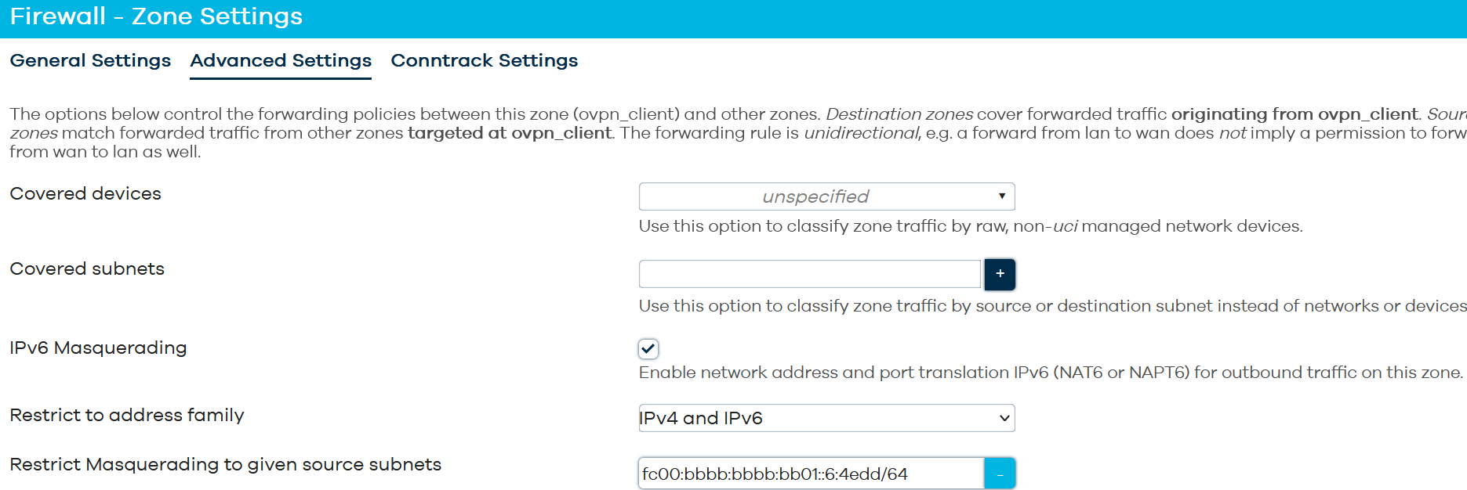
/etc/config/firewall:
config zone
option name 'wan'
option input 'REJECT'
option output 'ACCEPT'
option forward 'REJECT'
option masq '1'
option mtu_fix '1'
option masq6 '1'
list masq_src 'fc00:bbbb:bbbb:bb01::6:4edd/64'
list network 'wan'
list network 'wan6'
list network 'wg_proton_nl'

Click: Save and click Save & Apply

This should give you a working WireGuard Client

Check from the routers console with curl ipinfo.io and/or from your LAN clients with ipleak.net

Alternative Method
The Alternative method is to make a separate firewall zone for the VPN interface.
This can be useful if you want to make a killswitch (prevent traffic going out of the wan) or setup a Wireguard client on a Bridged AP.

Note that a killswitch is not really necessary as the WireGuard interface stays up even if there is no connection but it will add an extra layer of security and guards against mis-configuration.
Furthermore a killswitch is not compatible with Policy Based Routing (PBR).

Network > Firewall > Click: Add:
- Name: vpn_client
- Input: reject
- Output: accept
- Intra zone forward: reject
- Masquerading: enabled
- MSS clamping: enabled

- Allow forward from source zone: lan
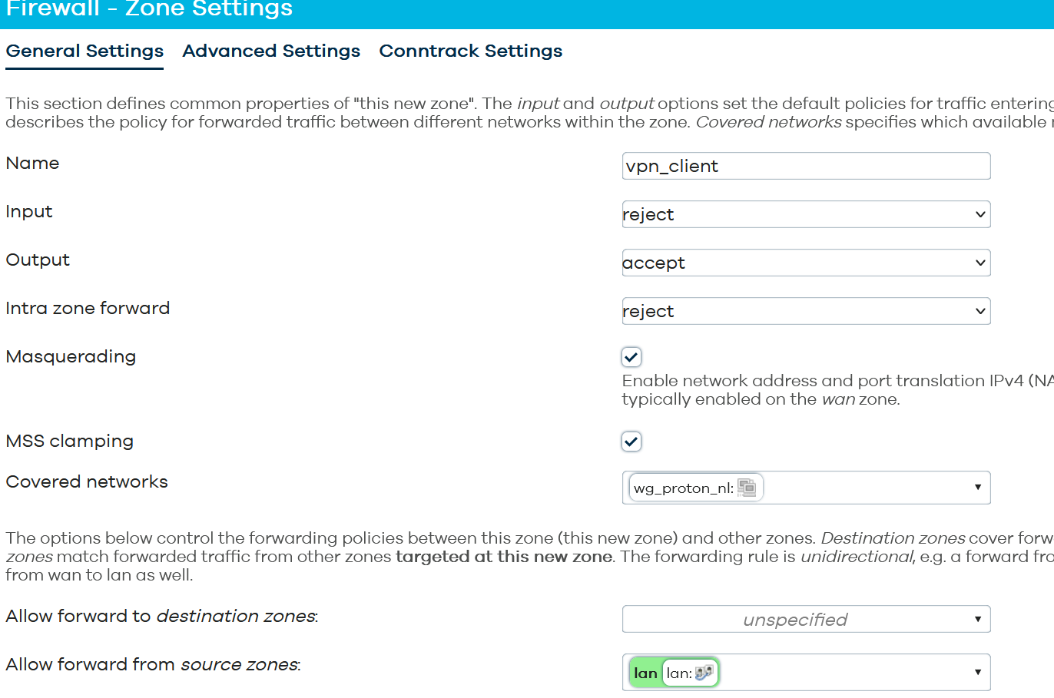

If your VPN provider also supports IPv6 (with ULA addresses) then on
Advanced Settings:
- IPv6 Masquerading: enable

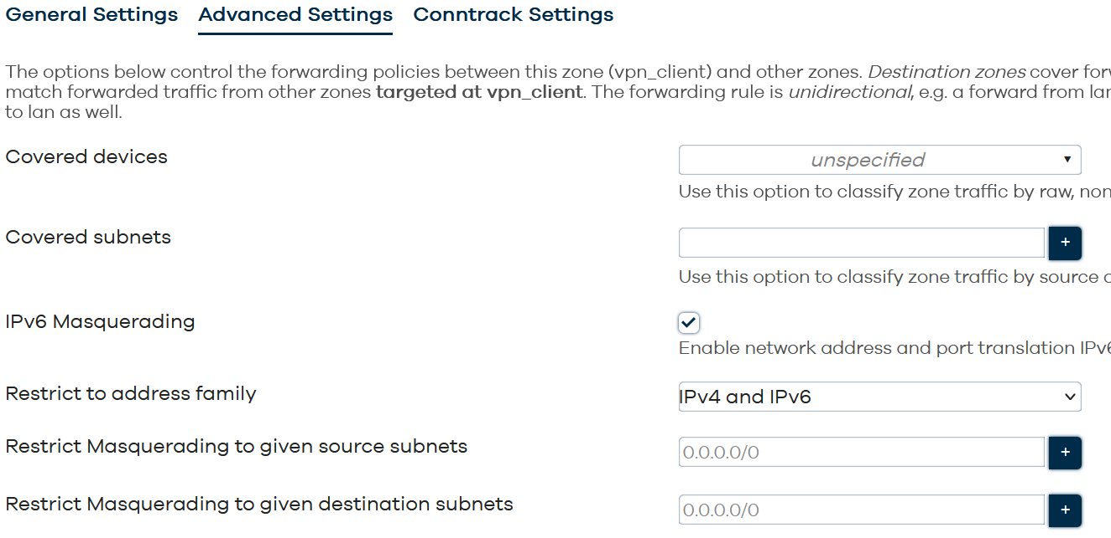

etc/config/firewall:
config zone
option name 'vpn_client'
option input 'REJECT'
option output 'ACCEPT'
option forward 'REJECT'
option masq '1'
option mtu_fix '1'
list network 'wg_proton_nl'
option masq6 '1'# only for IPv6

To prevent traffic going out of the wan (the Killswitch) Edit the lan firewall zone and disable forwarding to wan and only allow forwarding to the vpn_client zone.
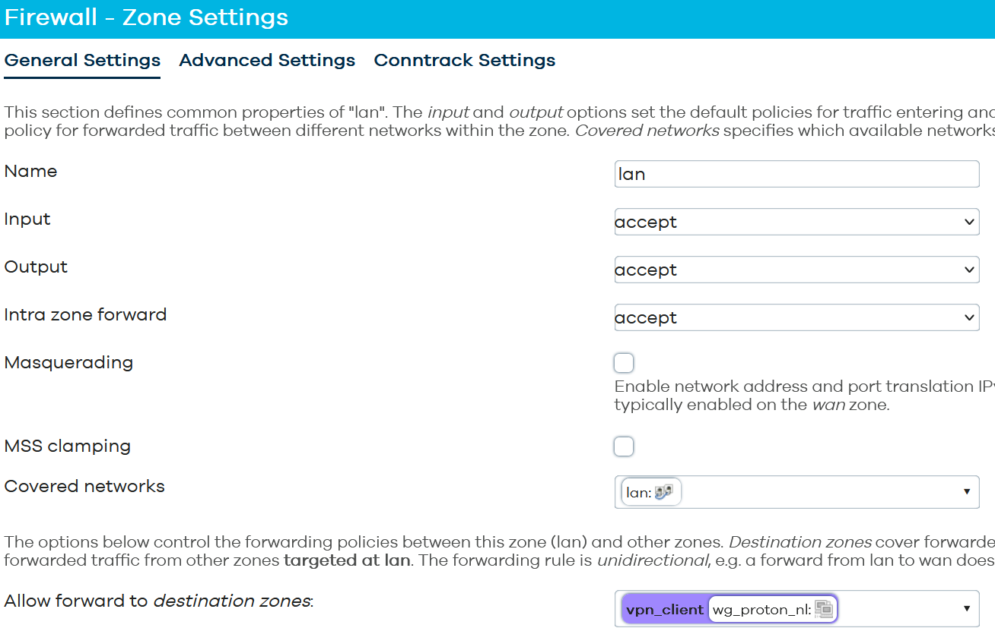
/etc/config/firewall:
config forwarding
option src 'lan'
option dest 'vpn_client'

Allowing Specific client(s) WAN access
If you want to let just specific lan clients to have WAN access e.g. in case of Policy Based Routing you can make a traffic rule with the IP of MAC addresses of that specifc lan client(s) e.g.:
etc/config/firewall:
config rule
option name 'allow_wan'
option src 'lan'
option src_ip '192.168.1.50/32' # for IPv4 use the IPv4 address
option src_mac '00:11:22:33:44:55' # for both IPv4 and IPv6 use the MAC address
option dest 'wan'
option target 'ACCEPT'

Make sure this rule is on top of the other rules, so add it before the other rules or use the GUI to drag the rule to the top.

Check
When everything is done Reboot the router and check that traffic flows:
Status > WireGuard:
You should see Latest Handshake with a new handshake every 3-4 minutes and traffic in both directions.
Or look at:
NetWork > Interface:
You should see traffic both for RX and TX indicating a working connection
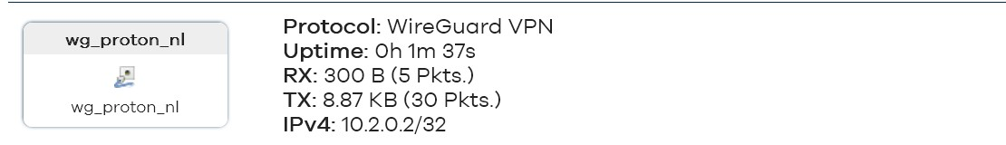

Check your lan clients by browsing to ipleak.net

DNS Leak
On a typical phone (Android, iOS) or Windows the DNS is just set on the WireGuard interface and the DNS set is used after the tunnel is up.
On the OpenWRT router things are much more complicated (in contrast to other third party firmwares which handles this much better)
For some background reading: https://github.com/egc112/OpenWRT-egc-add-on/tree/main/stop-dns-leak

Be very careful with using the DNS server from your VPN provider as sole DNS server if that DNS server is not publicly available as you might end up in a catch 22 situation because the router must have the correct time (more or less) before it can connect and to get the correct time it needs DNS resolving which is not available.
So in that case instead of a domain for time server use IP addresses ( System > System > Time Synchronization)
Of course if you stop the tunnel you do not have DNS resolution in that case you need a scripting solution to use the VPN DNS server after the tunnel is up.

WireGuard Client on a BridgedAP
If you want to setup a WireGuard Client on a BridgedAP, then be aware that normal traffic from your clients just bypasses your BridgedAP, so will not use the WireGuard tunnel unless you point the gateway of your clients to the BridgedAP (by using DNSMasq tagging with option 3 or iptables redirect) or setup a Guest Wifi on the BridgedAP.
In case of using a Guest wifi all clients using your Guest wifi will automatically use the WireGuard tunnel, so this is the more easier option.

First double check that you have setup your BridgedAP correctly see:
https://openwrt.org/docs/guide-user/network/wifi/wifiextenders/bridgedap

For a Guest Wifi on a BridgeAP see:
https://openwrt.org/docs/guide-user/network/wifi/guestwifi/guestwifi_dumbap
Setup the Guest wifi and check that it is working without WireGuard!
Note: do not forget to Enable Masquerading on the LAN zone

Setup a WireGuard client the regular way as described, but for firewall settings I recommend to use a separate zone for the WireGuard Interface (Alternative Method) as you need to enable MSS Clamping and then make a Forward rule to Forward from guest zone to vpn_client zone.
If you then remove the forwarding from guest zone to lan zone you will have an effective killswitch.

For IPv6 make sure your lan has an IPv6 with prefix delegated, the Guest interface will then get its own IPv6 address from Lan

Clients directly connected to the main router will bypass this router anyway but you can deal with this by manually setting the gateway on the client to point to your BridgedAP.
A second method is to have DNSMasq hand out a different gateway, this can be done per client with DNSMasq tagging with option 3( gateway), etc/config/dhcp"
config tag 'tag1'
option dhcp_option '3,ipaddress-of-BridgedAP'

config host
option name 'client1'
option mac '00:21:63:75:aa:17'
option ip '10.11.12.14'
option tag 'tag1'

The third method is by using policy based routing on the main router:
Create a routing table with default route via the BridgedAP and also local route for br-lan e.g.:
ip route add default via 192.168.0.9 table 2 # 192.168.0.9 is my BridgeAP
ip route add 192.168.0.0/24 dev br-lan table 2

For IPv6 routing you need the IPv6 address of the br-lan interface of the BridgedAP see: Setup IPv6 on a bridgedAP, you can get the address with `ifstatus lan 6 | grep address` or with ifconfig, you need the IPv6 address in the same subnet as the main router
This will get you a route like:
ip -6 route add default via 2001:8b11:234:1a33:a697:33ff:dcab:a3f2 dev br-lan table 2

Create a rule adding the lan clients involved to use this routing table 2 e.g.:
ip rule add 192.168.0.80 table 2 # 192.168.0.80 is the lan client I want to use the VPN

For IPv6 create the same rule with the IPv6 address of your client, unfortunately Windows uses its Temporary IPv6 address unless this is disabled and as it is temporary this is not a solid solution so disable the use of private IPv6 addresses e.g.:
ip -6 rule add from 2001:1ba2:236:a100::6f1 table 2

Make sure "Invalid traffic" is allowed or SNAT traffic from the LAN clients (e.g. 192.168.0.80) coming out of br-lan otherwise traffic can be blocked as there is asymmetric routing.

Policy Based Routing on the Bridged AP
When you have multiple Guest subnets on the router all will be routed via the WireGuard VPN. You can use Policy Based Routing just as if this was a regular router to route traffic to your liking via WireGuard or via the LAN to the main router.
Note: if you use the PBR app you have to set the lan interface as wan (option uplink_interface(6) 'lan(6)'). As `option lan_device` you might need to set the device which you want to route via the LAN instead of br-lan. See: https://forum.openwrt.org/t/guest-wifi-on-dumb-ap/242830/20?u=egc

Asking for Help
You can ask for help at the OpenWRT forum.

If you do, it helps if we can have a look at your configs, so please connect to your OpenWRT device using ssh and copy the output of the following commands and post it on the forum using the "Preformatted text </> " button

Remember to redact keys, passwords, MAC addresses and any public IP addresses you may have:
ubus call system board
cat /etc/config/network
cat /etc/config/wireless
cat /etc/config/firewall
wg show

To view the log for errors:
logread | grep -E -i 'netifd|wireguard'

References
https://openwrt.org/docs/guide-user/services/vpn/wireguard/start
https://openwrt.org/docs/guide-user/services/vpn/wireguard/basics
https://openwrt.org/docs/guide-user/services/vpn/wireguard/client

https://protonvpn.com/support/openwrt-wireguard

Miscellaneous

Setup IPv6 on a bridgedAP
/etc/config/network:
config interface 'lan6'
option ifname '@lan'
option proto 'dhcpv6'
#option reqprefix 'no'
option reqprefix '62' #for ipv6 guest interface
#option sourcefilter '0' # disable source routing for WG server routing of IPv6

Prevent Mullvad from hijacking your DNS
https://schnerring.net/blog/use-custom-dns-servers-with-mullvad-and-any-wireguard-client/

Port forwarding via Proton VPN with natpmpc
https://protonvpn.com/support/port-forwarding-manual-setup/
https://forum.openwrt.org/t/openwrt-protonvpn-and-pmp-port-forwarding-for-remote-ssh-access/229367

MTU size problems (no traffic, hang, slow loading, no streaming media, bad VoiP, slow RDP)
The MTU (Maximum Transmission Units) is the maximum datagram size in bytes that can be sent unfragmented over a particular network path, so to have the highest throughput you want the highest value without fragmentation.

But if the MTU is too high and the packets fragment this will manifest as connections which hang during periods of active usage, or does not load the whole page when browsing. Or you can connect but not see or use streaming media (like an IP Camera) or your connection is unexpected slow, VoIP can also be affected.
In the log you can see messages like: read UDP [EMSGSIZE path-MTU=1388]: Message too long (code=90) but that is not always present.

To test for the highest value basically use ping from a client on your local LAN, search for the maximum packetsize which can be send unfragmented , add 28 and that is your MTU value, see: https://hamy.io/post/000c/how-to-find-the-correct-mtu-and-mru-of-your-link/

ICMP blackhole test to see if PMTUD is working:
http://icmpcheck.popcount.org or http://icmpcheckv6.popcount.org/
Packet loss test: https://packetlosstest.com/

Android, Windows and iOS can use their own defaults so when having problems connecting from Windows, Android or iOS try to delete the MTU entry in the conf file and let the OS itself decide what to use.

WireGuard Watchdog
https://github.com/egc112/OpenWRT-egc-add-on/tree/main/wireguard-watchdog
Purpose: WireGuard watchdog with fail-over, by pinging every x seconds through the WireGuard interface, the WireGuard tunnel is monitored.
In case of failure of the WireGuard tunnel the next tunnel is automatically started.
When the last tunnel has failed, the script will start again with the first tunnel.
So in case you have only one tunnel this is just a watchdog which restarts the one tunnel you have.

with prioritizing :
https://forum.openwrt.org/t/bash-script-for-automatic-change-between-2-wireguard-tunnels/228696/11

WireGuard Companion
https://github.com/egc112/OpenWRT-egc-add-on/tree/main/wireguard-companion
Purpose: Toggle WireGuard tunnels on/off, show status and log.

Custom user files for Azure, AWS etc
https://forum.openwrt.org/t/policy-based-routing-pbr-package-discussion/140639/2051?u=egc

Centralized Management and Deployment
https://help.netmaker.io/en/articles/9773942-making-openwrt-successfully-integrate-with-the-netmaker-network

Binding WireGuard interface to specific wan interface in case of multiwan
When you have multiple wan interfaces the escape route for the enpoint address is sometimes made via the worng wan interface.
In this case you can add to the wireguard config e.g. : option tunlink 'wan'
binding the wireguard interface to this wan interface

